Fish from the sky: Airborne eDNA tracks aquatic life

Yin Cheong Aden Ip $​^{1}$**\***, Gledis Guri $​^{1}$**\*,** Elizabeth Andruszkiewicz Allan $​^{1}$, Ryan P. Kelly $​^{1}$

# 

| 1 | School of Marine and Environmental Affairs, University of Washington, Seattle, Washington, USA |
| --- | --- |
| * | shared first authorship |
|  |  |
|  | corresponding author **adenip@uw.edu** |

# Teaser

Aquatic life leaves traces in the air, opening a new paradigm shift on fate and transport of genetic material.

# Abstract

Water and air are generally treated as separate reservoirs of environmental DNA (eDNA) derived from the species resident in those respective environments. However, it is likely that eDNA routinely crosses the air-water boundary in both directions as a result of deposition, evaporation, or other processes. Here, we systematically tested methods of sampling eDNA at the air-water interface, showing for the first time that aquatic life can be reliably detected from passive air samples collected nearby. We deployed four simple air samplers — three different kinds of filters and one open tray of deionized water — alongside paired water samples and visual counts over a six-week peak run of Coho salmon (*Oncorhynchus kisutch*) at a local spawning stream. We then quantified eDNA concentrations in both air and water (air: copies/day/cm2; water: copies/L) using quantitative PCR, to estimate (1) the concentration of target eDNA in air vs. water, and (2) the capture performance of each filter type. Despite an approximate 25,000-times dilution versus water, passive air collectors captured quantitative airborne eDNA signals that closely paralleled salmon counts, although recovery varied with sampler design and orientation. We show the air-water interface is a quantifiable source of aquatic genetic information using simple, passive samplers that do not require electricity, making them appealing for biomonitoring in remote or resource-limited settings. This work points the way to using airborne eDNA as a robust pathway for biological information critical to conservation, resource management, and public-health protection.

**Keywords**: environmental DNA, Air eDNA, Passive Air Filtration, Aquatic Biomonitoring, Aerosolization, Evaporation, Non-invasive Sampling, Quantitative eDNA Analysis, Salmon, Environmental Genomics

# Introduction

Monitoring aquatic life is fundamental to understanding ecosystem health, guiding conservation efforts, and managing valuable natural resources1,2. Over the past decade, environmental DNA (eDNA) has upended our paradigm for biodiversity assessment by detecting and quantifying extra-organismal DNA through the genetic material they shed into their surroundings which can thereafter used to infer organismal abundance. Water-based eDNA surveys have proven particularly effective for monitoring endangered species3, early detection of invasive species incursions4, characterizing community composition5, and even providing quantitative assessments for complementing traditional surveys6–8.

Meanwhile, airborne eDNA research has emerged as a promising frontier, though to date it has focused almost exclusively on terrestrial organisms. Both active and passive air filtration methods have been shown to recover DNA from mammals, birds, insects, and plants under field and enclosed conditions9–15. Intriguingly, these same air-sampling techniques sometimes detect strictly aquatic taxa. For example,16 reported the occurrence of aquatic species in air eDNA samples, but the authors emphasized that the underlying mechanisms responsible for these detections remain unclear, suggesting multiple, non-exclusive scenarios including prey DNA and soil re-suspension. Yet in almost every case, these signals were never the focus of the study and are often treated as suspected contamination or attributed to zoo feed or piscivores fecal bioaerosols15,17–19, rather than recognized as a genuine ecological signal16. Yet, these overlooked detections can hint to an untapped source of real genetic material hence ecological inference.

Aquatic species signals detected in airborne eDNA surveys are often discarded*17*-21. Yet, these overlooked detections hint at a genuinely unexplored, rich, untapped source of data for a complementary biodiversity monitoring approach. Environmental systems are inherently interconnected20, and basic physics points to towards aquatic DNA should appear in air21,22. Natural physical processes at the air-water interface, such as evaporation, bubble-burst aerosolization from riffles and biological processes such as splashes, and leaping fish, churning substrates, create splash-driven aerosols; all of these provide plausible mechanisms for transferring eDNA into the atmosphere23–26. Despite unprecedented parallel advances in aquatic and airborne eDNA research18,19,27,28, the question of whether aquatic genetic material can naturally transfer across media into the air remains untested. Without an investigation, these "unexpected" aquatic signals in airborne eDNA data are often overlooked, resulting in an oversight that risks discarding a signal, potentially indicative of biological activity. Confirming cross-media transfer would open new frontiers in ecology, further extend eDNA monitoring, and provide a more comprehensive understanding of the state and fate of genetic material in the environment.

To test this hypothesis, we conducted the first targeted investigation of cross-medium water-to-air eDNA transfer, specifically examining whether genetic material from aquatic organisms can be detected in air samples collected above water surfaces. Leveraging the behavior of Coho salmon (*Oncorhynchus kisutch*) during their spawning season24, we collected and measured eDNA concentrations in paired water and passive air samples over a six-week peak migration period, with visual fish counts from hatchery staff. To evaluate the mechanisms of airborne DNA capture and settlement, we deployed four passive air collection methods: vertically orientated gelatin air filters (commonly used in low-flow air filtration systems), polytetrafluoroethylene filters (PTFE; standard in high-flow air applications), and mixed cellulose ester filters (MCE; traditionally employed for water filtration), as well as an open, horizontal tray of deionized water exposed to ambient conditions18. These were chosen for their distinct physical properties, contrasting orientations, and different particle capture efficiencies targeting different aerosol types. By comparing detection sensitivity, temporal patterns, and quantitative performance of these four collectors against water eDNA concentrations and visual counts, we tested if airborne eDNA can reliably track real-world aquatic population dynamics and which filter type would track biological signal most appropriately.

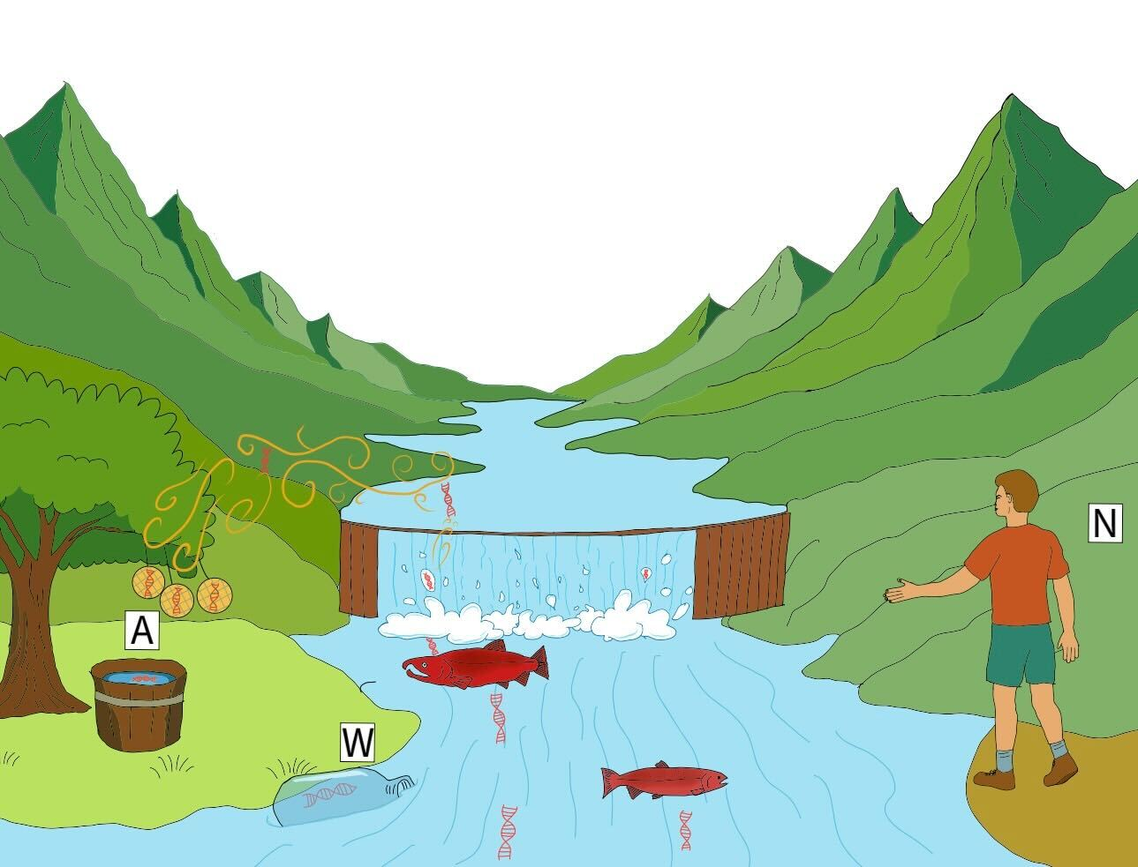

Figure 1: Conceptual illustration of cross‐medium eDNA sampling above a salmon‐spawning stream. Natural processes, including evaporation, bubble-burst aerosolization at riffles and splashes, and the vigorous movement of spawning Coho salmon, launch trace amounts of DNA from the river surface into the atmosphere. Passive airborne samplers, shown here as three vertically hung filters and an open tray of deionized water (A), intercept settling airborne eDNA, while paired water-grab sampling (W) and visual counts by hatchery staff (N) provide concurrent reference measurements.

# Methods

## Field Sampling

We conducted this study near Seattle, Washington USA, in Issaquah Creek, a salmon spawning stream, outside of the Issaquah Salmon Hatchery (47.529501 $​^{∘}$ N, 122.039133 $​^{∘}$ W) from 17 October 2024 to 21 November 2024, with six sampling events. We chose six field trips that spanned the entire coho salmon (*Oncorhynchus kisutch*) run, from the first arrivals in early fall of August, through peak abundance around 17 October 2024 and into the tail end of the migration in November. This schedule ensured that our eDNA sampling captured both the lowest and highest levels of fish activity. Within the same sampling period, visual fish counts were performed by the hatchery staff, and salmon escapement data were obtained from the Washington Department of Fish and Wildlife escapement reports (<https://wdfw.wa.gov/fishing/management/hatcheries/escapement#2024-weekly>). Throughout our six sampling events, weather conditions ranged from clear, calm days to periods of rainfall; detailed records of air temperature, wind speed, relative humidity, and precipitation are provided in ([SI Appendix, Table. S2](SI_Appendix.pdf))

### **Airborne eDNA sampling**

Sampling for eDNA was conducted in 24-hour blocks with deployment and recovery around 9 a.m. (river water was collected only on the first day/timepoint). Four passive collection methods were evaluated: three filter types—gelatin (Sartorius, 47 mm diameter), PTFE (Whatman, 47 mm diameter), and MCE (Sterlitech, 5.0 $μ$ m pore size, 45mm diameter)—and an open container of deionized water. The rationale for selecting these materials is as follows: gelatin filters are effective at capturing airborne particles and are particularly suited for applications where maintaining viability (e.g., for subsequent bacterial culturing;29) is desired; PTFE filters are noted for their high durability and are widely used in active air sampling experiments30; whereas MCE filters, typically employed for water filtration, were included to assess their performance in an airborne context6. All three passive filters were deployed via custom 3D-printed “honeycomb” puck filter holders, based on open-source Thingiverse designs (IDs 4306478 and 979318; Zachary Gold, pers. comms.), and were suspended from a hatchery railing approximately 3 m above the river water level (Figure 1), with their collection surfaces oriented horizontally. All three passive filters were deployed via 3D-printed “honeycomb” puck holders, based on open-source Thingiverse designs (IDs 4306478 and 979318)

This configuration minimizes splash contamination and captures airborne DNA particles driven by gravitational settling. The positioning relative to flowing water demonstrates how these passive collectors operate at a vantage point above the stream, facilitating non-invasive DNA capture in real-world field conditions. Two biological replicates were deployed for both gelatin and PTFE, while only one replicate was used for MCE. After the overnight deployment, filters were carefully recovered using sterile, disposable forceps and immediately immersed in 1.5 mL of DNA/RNA Shield.

The fourth passive collection method was an open container (25 cm width, 30 cm length, 10 cm depth) filled with 2 L of deionized water18 also positioned about 3 m above the river and about 30 cm above the suspended passive filters. The open container was also deployed for about 24 hours at the same times as the passive filters. The container had an open surface (i.e., oriented horizontally) to capture airborne particles settling by gravity. The surface area of the container was approximately 750 cm $​^{2}$, in contrast to the roughly 16 cm $​^{2}$ surface area offered by the 47-mm circular filter disks. Only one replicate was used for the open water container method. Note that although 2 L of deionized water was placed in the container, heavy rainfall during overnight deployments sometimes increased the water level. Any debris (e.g., bugs, leaves) was removed from the container before on-site filtration using the same system as for river water samples (see below for details).

### **Water eDNA sampling**

Concurrent with airborne sampling, water samples were collected by pulling 3L of water from the river, using sterile water bottles, directly adjacent to the coho salmon aggregation school, just downstream of the fish ladder entrance. The ladder is operated continuously by hatchery staff throughout the salmon run, ensuring fish passage and visual counts. A total of 3 L of water was filtered on site using a Smith-Root Citizen Science Sampler equipped with 5.0 µm mixed cellulose ester (MCE) filters6. Three 1 L replicates were processed and immediately preserved in 1.5 mL of DNA/RNA Shield (Zymo Research) using clean disposable plastic forceps. Field-negative filtration blanks (1 L of Milli-Q water each) were also processed using the same system. All equipment was decontaminated with 10% bleach, thoroughly rinsed with deionized water, and handled with gloves to minimize contamination. All filters (passive air, passive open container, water) were stored at –20 $​^{∘}$ C until processing, typically within one week.

## Wet-Laboratory Procedures

DNA extraction from both river water samples and airborne filter samples was performed using the Qiagen Blood and Tissue Kit according to the manufacturer’s protocols. During extraction, it was noted that the gelatin filters dissolved completely in the DNA/RNA Shield. Samples were vortexed for 1 minute, and 500 $μ$ L of the shield was used for DNA extraction.

qPCR assays targeted a 114-bp fragment of the cytochrome b gene of coho salmon, using primers derived from31— COCytb_980-1093 Forward: CCTTGGTGGCGGATATACTTATCTTA and COCytb_980-1093 Reverse: GAACTAGGAAGATGGCGAAGTAGATC. SYBR Green chemistry was employed using SYBR Select Master Mix (Fisher Scientific) on an Applied Biosystems QuantStudio 5 real-time PCR system with a 384-well block. Each 10 $μ$ L reaction consisted of 5 $μ$ L of SYBR Select Master Mix, 0.4 $μ$ L of 10 mM forward primer, 0.4 $μ$ L of 10 mM reverse primer, 2.2 $μ$ L of molecular grade water, and 2 $μ$ L of DNA template. Melt curve analysis was performed to confirm the amplification of the target fragment, with an accepted melting temperature of 81 $​^{∘}$ C ± 1 $​^{∘}$ C.

Standard curves were constructed using a coho tissue DNA extract quantified with a Qubit fluorometer [SI Appendix, Fig. S6](SI_Appendix.pdf). The stock solution was diluted to 1.0 ng/ $μ$ L and designated as 10 $​^{6}$ copies/ $μ$ L. Serial dilutions were then prepared, with 10 $​^{5}$, 10 $​^{4}$, and 10 $​^{3}$ copies/ $μ$ L run in triplicate, 10 $​^{2}$ copies/ $μ$ L in quadruplicate, and 10 $​^{1}$/ $μ$ L copies in triplicate.

## Joint statistical model

### ***Visual observation model***

In summary, we synthesize three methods of observations (visual counting of fish, water eDNA measurements, and air eDNA measurements) which derive from a single unknown true fish accumulation rate (denoted here as $X$). Through this joint approach, we can estimate: the aerosolization factor ($η$; the magnitude of water eDNA transferred to air), the effectiveness and reliability of different passive air filtering techniques ($τ$), and the replicability of various filters ($ρ$) throughout the 6-week peak coho salmon spawning period.

We model the upstream migration of coho salmon (Oncorhynchus kisutch) as arising from the inferred unknown true density of fish. As individuals move upriver, fish accumulate in a holding area immediately downstream of the hatchery river dam (our water and air sampling location). At discrete times $t$, the hatchery staff opens the ladder gate to allow passage into holding tanks. Between successive gate-opening events ($Δt$), additional coho salmon arrive and join the backlog in the holding area, increasing the number of individuals awaiting passage. Let $X$ represent the true daily accumulation rate (also fish density at the river dam) in units of fish/day at time $t$, and let denote the counting effort (measured as the elapsed number of days between consecutive gate openings;; hence $E_{t=1}=0$). Prior to each gate opening (at time t, across six weekly sampling points from October 17th to November 21st), the crew conducts a visual count $N_{t}$ of accumulated fish. Assuming $X_{t}$ remains relatively constant between successive gate-opening events ($Δt$), we model the observed fish counts as a Negative Binomial process:

$$\begin{aligned}λ_{t}=X_{t}⋅E_{t} \#\left(1\right)\end{aligned}$$

$$\begin{aligned}N_{t}∼Negative Binomial\left(λ_{t},ϕ\right)\#\left(2\right)\end{aligned}$$

where, $N$ is the visually observed number of fish at time $t$, $λ_{t}$ is the expected number of fish accumulated over the $E_{t}$-day interval with a fixed overdispersion parameter shared across time points ($ϕ=20$; hence variance )7,32

### ***Molecular process model***

Let $W$ be the unobserved eDNA concentration (copies/L) in the water at time $t$ and let $ω$ be the “integrated eDNA factor" – the conversion factor between $X$ and (see7 for further interpretation of this parameter). We can express the relation between the fish density and water eDNA concentration as:

$$\begin{aligned}W_{t}=X_{t}⋅ω \#\left(3\right)\end{aligned}$$

Let $A$ be the unobserved eDNA concentration (copies/day/cm $​^{2}$) in the air at time $t$ that is filtered using passive collection method $j$. We model the air eDNA concentration as a log-linear function of the water eDNA with intercept $η$, slope = 1, and error term $ε$ (unexplained variability; time and filter specific):

$$\begin{aligned}ln\left(A_{tj}\right)=η_{j}+ln\left(W_{t}\right)+ε_{tj}\#\left(4\right)\end{aligned}$$

Here the intercept $η$ can be interpreted as the water-to-air transferability (or dilution) factor and $ε$ as the error term parameter (similar to the sum of squares error) from a linear regression where $ε_{tj}∼N(0,τ_{j})$.

For some filter types $j$ (PTFE filters ($j=P)$; gelatin filters ($j=G$)) we sampled two biological replicates and we used the mean of those biological replicates to determine the average concentration in the air $A$ at time $t$ as following:

$$\begin{aligned}ln\left(A_{tjb}\right)=ln\left(A_{tj}\right)+δ_{tjb} \text{for} j∈\left\{P,G\right\}\#\left(5\right)\end{aligned}$$

where $δ_{b}$ indicates the deviation of individual biological replicate from the average concentration ($A_{tj}$), following a normal distribution with mean 0, $δ_{tjb}∼N(0,ρ_{j})$, with $ρ_{j}$ indicating the magnitude of the replicates deviation from the mean sample. Because we have only two replicates at each sampled time, we impose a sum to zero constraint on the replicates ($b$) collected from a single sampling time ().

To estimate the levels of eDNA concentration in water ($W$) and air ($A$), we make use of the qPCR observation models (as described in33,34, with slight modifications). The model compartment uses the standard curve samples to estimate the intercept ($ϕ,β0,γ0$) and slope ($β1,γ1$) parameters between the known concentration ($K$) and the observed data ( $Z$ and $Y$) from qPCR machine as follows:

$$\begin{aligned}Z_{kr}&∼Bernoulli\left(ψ_{k}\right) \#\left(6\right) \\ ψ_{k}&=1-exp\left(-K_{k}⋅θ\right)\#\left(7\right) \\ Y_{kr}&∼Normal\left(μ_{k},σ_{k}\right) \text{if }Z_{kr}=1 \#\left(8\right) \\ μ_{k}&=β_{0}+β_{1p}⋅ln\left(K_{k}\right)\#\left(9\right) \\ σ_{k}&=exp\left(γ_{0}+γ_{1}⋅ln\left(K_{k}\right)\right)\#\left(10\right)\end{aligned}$$

where $Z$ is the binary outcome of target amplification for sample ($k$) and technical replicate ($r$) being present (1) or absent (0) following a Bernoulli distribution given the probability of detection $ψ$ for each sample ($k$). The parameter $ϕ$ is the intercept of the function between probability of detection $ψ$ and the known DNA concentration ($K$; copies/ $μ$ L reaction) as the predictor variable. Additionally, for equations 8-10, $Y$ is the observed cycle threshold (Ct) for sample ($k$) and technical replicate ($r$) which follows a normal distribution with mean $μ$ (mean Ct) and standard deviation $σ$ for each sample ($k$). We model $μ$ as a linear function of known eDNA concentration ($K$) with intercept $β0$ and plate specific ($p$) slope $β1$ and the standard deviation $σ$ of the observed Y as an exponential function of known eDNA concentration with intercept $γ0$ and slope $γ1$.

Subsequently, we build the same model compartment for estimating eDNA concentration in water and air by substituting $U_{t}$ and $Q_{tj}$ (and $Q_{tjb}$ for $j∈\{P,G\}$) respectively, with $K_{k}$ through equation 6-10 (see [SI Appendix, Fig. S1](SI_Appendix.pdf)), where $U$ and $Q$ are concentration normalized per reaction volume ( $V$ = 10 $μ$ L) and surface area ( $S$ = 16 cm $​^{2}$ for gelatin, PTFE, and MCE, and 750 cm $​^{2}$ for the open containers of deionized water) of $W$ and $A$ respectively as follows:

$$\begin{aligned}U_{t}&=W_{t}/V_{itp}\#\left(11\right) \\ Q_{tjb}&=A_{tjb}⋅S_{tj}/V_{tjbrp}\#\#(12)\end{aligned}$$

The intercept and slope parameters (from equation 7, 9, and 10) between qPCR observations and eDNA concentration of water, air and the standard samples are shared between model compartments.

## Model conditions

The joint model ([SI Appendix, Fig. S1](SI_Appendix.pdf)) was implemented using the Stan language as implemented in R (package: Rstan) running four independent MCMC chains using 5000 warm-up and 5000 sampling iterations (for parameters and their prior distribution see [SI Appendix, Table S1](SI_Appendix.pdf)). The posterior predictions were diagnosed using statistics (Gelman and Rubin 1992) and considered convergence for values less than 1.05 and effective sample size (ESS) greater than 1000 for all parameters. Additionally, the posterior predictive checks were used with results presented in the [SI Appendix, Fig. S5](SI_Appendix.pdf).

# Results

Airborne eDNA passively detected Coho salmon and closely mirrored their abundance in the river during the upstream migration period. Detection efficiency and signal strength varied considerably among the different passive airborne eDNA capture methods.

## Fish accumulation based on visual counts and eDNA in river water

Coho salmon migration occurs not as a single continuous event, but rather as a series of distinct burst peaks from mid-October through late November, where the peaks are highly likely to be connected with environmental factors such as water temperature and discharge. The average daily accumulation rate (X; black line in Figure 2) was estimated at 160.4 fish/day with peaks exceeding up to 286 fish/day and low activity of ca. 78 fish/day (Figure 2).

Because both observation methods (river water eDNA and visual observation) are jointly used to estimate the daily accumulation rate (X), their concordance was best evaluated through the parameter $ω$. A converged and narrowly distributed $ω$ parameter indicates strong agreement between the two methods and simultaneously a reliable conversion parameter from fish/day to eDNA copies/L. In this case, $ω$ = 9.578 (95% quantile range of 9.352 to 9.804; ([SI Appendix, Fig. S4](SI_Appendix.pdf))), suggesting consistent concordance between observed fish counts and eDNA concentrations hence, biologically, this implies that an accumulation rate of 1 fish/day corresponds to approximately 15000 ( $±$ 3000) copies/L.

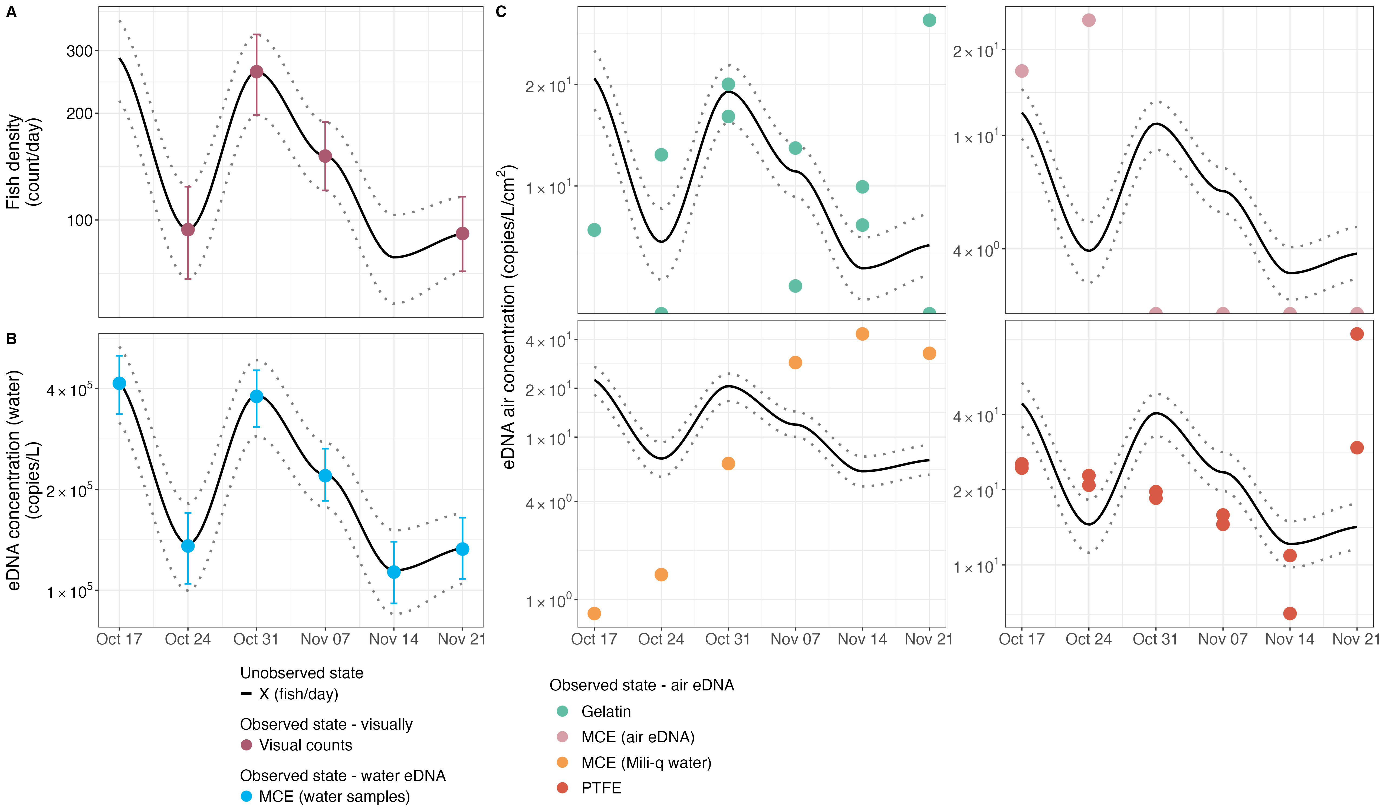

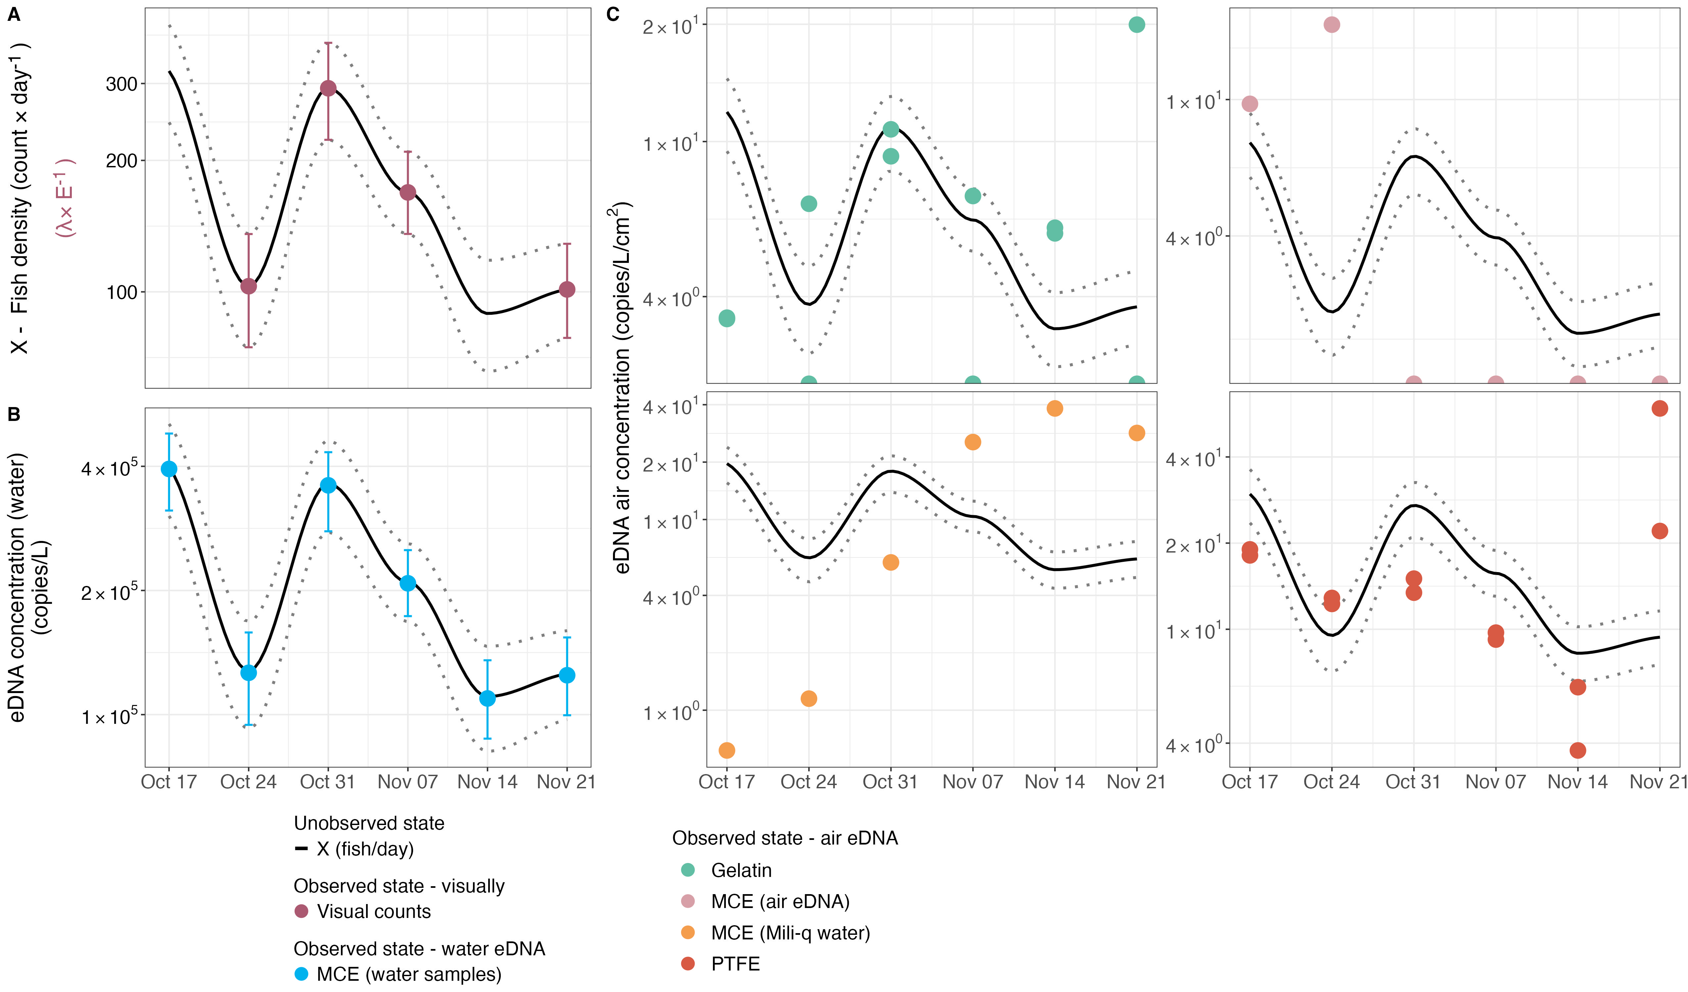

Figure 2: The temporal dynamics of estimated fish density in units of fish/day (X; black line with 95 confidence intervals - dotted lines) from October 17 $​^{th}$ to November 21 $​^{st}$ compared to the posterior distributions of visual observations (A), eDNA concentrations (copies/L) in water (B), and eDNA concentrations (copies/day/cm $​^{2}$) in air using various filter types (C).

## Air eDNA signals

Airborne eDNA originating from coho salmon was successfully detected across all passive air collection methods deployed (gelatin, PTFE, MCE filters suspended in air, and open containers of deionized water - MCE DI water). All filter types demonstrated that airborne eDNA concentrations were approximately e $​^{-10.21}$ ($\overline{η}=10.21$) lower than corresponding waternborne eDNA concentrations, establishing a quantifiable dilution factor between water and air matrices. On average 1 copies/day/cm $​^{2}$ captured in air is equivalent to ca. 25,000 copies/L in water. Despite the general consistency in estimating the water-to-air dilution coefficient, method-specific variations in collection efficiency were observed (Table 1; [SI Appendix, Fig. S2](SI_Appendix.pdf)*[A](SI_Appendix.pdf)*). PTFE filters exhibited higher capture efficiencies, collecting 2 times more eDNA than the mean across all air sampling methods (Table 1). Deionized water tray (MCE DI water) demonstrated the second highest efficiency (1.3 times the average; Table 1), while gelatin filters and air suspended MCE filters showed comparatively lower capture efficacy (0.8 and 0.5 times the average, respectively; Table 1).

In terms of alignment with the biological activity, PTFE and gelatin filters best mirrored the daily fish accumulation patterns, exhibiting the lowest residual error magnitude (expressed as the standard deviation of $ε$) with $τ$ = 0.473 and 0.570, respectively (Table 1; [SI Appendix, Fig. S2*B*](SI_Appendix.pdf)). Conversely, MCE DI water, despite having the largest surface area, showed less agreement with the fish migration dynamics ( $τ$ = 1.780; Table 1; [SI Appendix, Fig. S2*B*](SI_Appendix.pdf)). The MCE air suspended filters performed least effectively in tracking temporal migration patterns, failing to amplify coho salmon DNA beyond the first two weeks of the sampling campaign Figure 2*C*.

Subsequently, biological replicates for gelatin and PTFE filters revealed additional insights regarding methodological robustness and reproducibility. PTFE filters produced the most consistent quantifications, with lower variance (expressed as the standard deviation of $δ$) between replicates ( $ρ$ = 0.154; Table 1; [SI Appendix, Fig. S2*C*](SI_Appendix.pdf)), whereas gelatin filters showed a higher degree of variability ( $ρ$ = 0.386; Table 1; [SI Appendix, Fig. S2*C*](SI_Appendix.pdf)), indicating reduced reproducibility of quantitative outcomes.

In sum, these performance differences across sampling methods likely reflect inherent physical and operational characteristics of each filter type and collection method, which in turn influence their ability to capture either discrete or cumulative biological signals from the source species.

Estimated posterior means of dilution parameter ($η$), standard deviation of the residuals ($τ$), biological replicability ($ρ$), and capturing efficiency ($e^{(η-\overline{η})}$)

|  |  |  |  |  |
| --- | --- | --- | --- | --- |
| **Filter type** | **Dilution**  **(in $log_{e}$)** | **Standard**  **deviation** | **Biological rep.**  **error magnitude** | **Capturing**  **efficiency** |
|  | **($η$)** | **($τ$)** | **($ρ$)** | $$e^{(η-\overline{η})}$$ |
| Gelatin | $$-10.45$$ | 0.473 | 0.386 | 0.785 |
| PTFE | $$-9.53$$ | 0.570 | 0.154 | 1.979 |
| MCE Air | $$-10.91$$ | 0.949 | - | 0.496 |
| MCE DI water | $$-9.95$$ | 1.780 | - | 1.295 |

## 

## Model diagnostics

Convergence and reliability of the Bayesian model were assessed through comprehensive diagnostics. All parameters ([SI Appendix, Table S1](SI_Appendix.pdf)) exhibited reliable Gelman-Rubin convergence statistics ($\hat{R}<1.01$) and effective sample sizes (ESS) exceeding 1000 per parameter, indicating successful convergence and efficient mixing of the six independent chains ([SI Appendix, Fig. S3](SI_Appendix.pdf)*[A](SI_Appendix.pdf)*). No divergent transitions were detected during sampling, and the maximum tree depth was not exceeded, indicating no issues with divergence or exploration limits ([SI Appendix, Fig. S3](SI_Appendix.pdf)*[B](SI_Appendix.pdf)*). The posterior likelihood demonstrated convergence before the sampling phase began, with all chains exhibiting high mixing, confirming robust exploration of the parameter space ([SI Appendix, Fig. S3](SI_Appendix.pdf)*[B](SI_Appendix.pdf)*).

Prior sensitivity analyses revealed that posterior estimates differed from priors, demonstrating that the posteriors were appropriately updated based on the observed data rather than being heavily influenced by prior assumptions ([SI Appendix, Fig. S4](SI_Appendix.pdf)). Additionally, the posterior predictive checks (PPC) demonstrated that the model reliably reproduced the observed data, supporting the validity of parameter estimates ([SI Appendix, Fig. S5](SI_Appendix.pdf)). Collectively, these diagnostics confirm the reliability and validity of the Bayesian model used here.

# Discussion

## A new dimension of biodiversity monitoring

Our study establishes, for the first time, that passive airborne eDNA sampling can reliably capture and track molecular signals from aquatic organisms, providing compelling proof-of-concept that fully passive airborne eDNA sampling – without active airflow systems – can detect genetic material from aquatic organisms (i.e., salmonids here) and extends further with quantitative demonstrations that reflect actual population dynamics. This represents a paradigm shift in how we access aquatic biodiversity – through the air, without ever touching the water. In salmon-spawning streams, genetic material from the river is transported into the air likely by evaporation, bubble-burst aerosolization at riffles and splashes, and the rigorous churning of spawning fish35,36. Collections from multiple passive samplers, when compared with conventional water-based eDNA assays and daily visual counts, reveal a clear and quantitative relationship between airborne eDNA concentration and salmon density.

Until now, airborne eDNA surveys have reported fish or other strictly aquatic taxa as likely to be laboratory contamination, zoo-feed artifacts, or piscivore fecal bioaerosols15,17–19. Our data suggest otherwise: this is a real ecological signal rather than an experimental artifact. Additionally, it is likely that environmental conditions such as wind speed, relative humidity, and temperature can determine the spatial and temporal distribution of the aerosolized aquatic eDNA37,38. For example, high humidity and rainfall force rapid settling and very localized deposition while dry, windy conditions might carry genetic plumes further distances downwind39,40. Although quantifying these effects was beyond the scope of this study, they – together with hydrological variables – should be considered when evaluating how passive samplers capture transient pulses of biological activity.

## Sampler design shapes signal detection

In concordance with other studies tracking real biological life41, our 24-hour deployments passive filters (vertically oriented gelatin and PTFE) acted as higher-resolution “fish-activity” samplers. Such process can occur due to ambient air currents likely sweeping fine, splash-generated aerosols rich in salmon DNA onto filter membranes, yielding traces of DNA that could rise and fall in sync with live fish counts and water-eDNA levels42. In contrast, the large horizontal tray of deionized water seemed to function more like a hydraulic-driven deposition trap. The tray saw a steady accumulation of eDNA over the six weeks and thus could have been collecting more coarse spray, foam, and decay-derived particulates from river turbulence and from decomposing carcasses36,43. Because salmon carcasses often remain in shallow banks and backwaters as the spawning season progresses, it is plausible that river turbulence and discharge could generate larger droplets over decomposing tissue, potentially facilitating eDNA dispersal35,44. Although to our knowledge there is no study that has investigated this process in particular, we hypothesize that the coarse droplets settle rapidly and dominate deposition on horizontal collectors while the fine fraction produced by active fish movement could be more volatile and under-represented. This could explain that Gelatin and PTFE filters indicating more likely snapshots of biologically driven eDNA flux whereas the water tray integration of both flow-driven and decay-driven inputs into a steadily rising accumulation curve.

The filter materials and operational context also shaped the air sampling performance. PTFE filters, known for their durability, delivered the most consistent results of all the passive filtration methods; gelatin filters yielded the highest sensitivity but showed greater variability; mixed cellulose ester filters captured negligible airborne DNA; and the open tray, with roughly 50 times more surface area than the vertical filters, recovered the highest total DNA yield. These samplers can respond differently to weather primarily due to their material composition. In the physical form, through our visual observations when handling the air samples, PTFE filters are generally unaffected by rain (always intact when retrieved), whereas gelatin filters typically dissolve when wet. Additionally, the environmental variables might introduce some untestable trade-offs. For example, heavy rain can dilute the accumulated eDNA but may also scour additional airborne or splash-borne DNA into the water. Real-world debris, such as leaves, insects, sediment, can also wash into the tray, increasing the risk of clogging or necessitating pre-filtration before DNA extraction. Although our sample size is too small to quantify these opposing effects, future work should explicitly test how precipitation intensity influences both concentration and total yield12.

## Airborne eDNA as a fraction of waterborne eDNA

On average (among all airborne eDNA capturing approaches), our data showed that eDNA in the air was roughly 25,000 times less concentrated than in the water, at a level that approaches the lower limits of qPCR detection. Despite this extreme dilution, our rigorous sampling, laboratory methods, and statistical models reliably picked up those sparse molecules, obtaining consistent, quantitative signals across the entire spawning season. To put this in perspective, dissolving a teaspoon of salt into a large aquarium yields a similar dilution magnitude: only a tiny fraction of shed DNA ever makes it into the overlying air, yet those few copies suffice to track real-time salmon activity. In particular, vertically oriented filters intercepted transient eDNA peaks that rose and fell in concert with visual counts, demonstrating that even at extreme dilution, airborne eDNA can still capture fine scale changes in fish presence that reflects real-world population dynamics.

Longer passive‐sampler deployments naturally accumulate more settled eDNA, but they also expose collected material to ultraviolet radiation, microbial degradation and fluctuating humidity, all of which erode DNA integrity over time45.46 showed that waterborne eDNA degrades with a half‐life of hours to days under natural sunlight and microbial loads, suggesting that once deposited on the filter, airborne fragments may decay on comparable or even faster timescales. By contrast,18 found that passive air particle collections continued to accrue new species detections for up to 96 hours, without specifying when deposition begins to be outpaced by degradation. In practical terms, this could mean that in a longer deployment much of the DNA captured from early days may degrade before retrieval which potentially can skew the majority of signal by reflecting material deposited in the final timespan of sampling. Here we show that selecting a 24‐hour deployment is sufficient for capturing biological signals which might alleviate the potential limiting factor of post‐deposition loss12. However, future work should shed light on these plausible interpretation where studies employ varying deployment lengths from a few hours to several days, and pair them with controlled decay assays, for example by spiking synthetic DNA onto filters and tracking its persistence, to determine the point at which accumulation and degradation balance.

Our findings also agree with the recent work by41 who showed that passive air samplers outperform active pumps by sampling intermittent, DNA-rich plumes over long intervals and detecting greater species richness. In our streams, vertical filters captured transient bursts of salmon eDNA in near real-time, while the open tray, and likely longer deployments, would tend to smooth those peaks into an integrated signal. Contrastingly, active-pump systems operating for only hours would average across plumes and risk overlooking fine-scale temporal changes.

By systematically mapping this interplay between deposition and degradation, and by benchmarking passive against active approaches, we can establish best‐practice guidelines for airborne eDNA sampling durations. This effort would mirror how water‐based eDNA workflows define optimal filtration volumes and storage times27,47 and would enable robust, context‐specific deployments that maximize genuine signal recovery for real‐time biodiversity monitoring.

## Minimal tools, maximum reach and navigating limitations

Perhaps the most striking result from our work is the simplicity and versatility of passive airborne sampling. No pumps or power are needed, and equipment is extremely low cost and easy to deploy. This minimal-infrastructure approach makes it viable for remote headwaters, steep mountain channels, urban stormwater networks, and contaminated waters where sampling is unsafe48,49. Despite this being the first study to explore the link between water-to-air eDNA migration, this could open opportunities for future monitoring scenarios where access to water is limited (e.g., droughts, floods and public-health risks such as bacterial outbreaks in stagnant waters, airborne eDNA offers resilient pathways for rapid invasive-species alerts, real-time disease surveillance in flood-prone wetlands and non-invasive population censuses in protected spawning grounds.

Naturally, challenges remain, as passive deployments rely on surface-area-by-time metrics rather than standardized air-volume units, complicating direct comparisons across studies. Optimal exposure times must balance accumulation against DNA degradation from UV, microbes and moisture45. Weather variability in wind, humidity and rain can alter deposition rates and sampler efficiency12,Further studies have to shed light on environmental conditions (i.e., temperature, humidity, seasons, etc.) refine sampler design, systematically compare vertical and horizontal orientations, explore automated or drone-based retrieval and integrate river discharge and meteorological data into quantitative models35,39,50,51.

Our study begins to chart a portion of airborne eDNA ecology’s in five key dimensions28. We confirm origin by matching airborne DNA trends to co-occurring water eDNA and fish counts. We elucidate transport mechanisms such as evaporation, bubble bursts and fish activity. We quantify dispersal and dilution by measuring a 25,000-times concentration difference between water and air samples. We demonstrate fate through differential deposition on vertical filters and horizontal trays. Finally, we show that airborne DNA fragments remain amplifiable, offering an initial glimpse into their molecular state after transport. The potential underlying process suggest that air could act as a diluted, but still informative, extension of the aquatic environment, representing biological signals that are real, quantifiable, and ecologically meaningful. These insights lay the groundwork for future studies on persistence, degradation and particle-size distributions from airborne eDNA52.

Overall, our work overturns the assumption that aquatic eDNA belongs solely underwater. By demonstrating that genetic signals from Coho salmon routinely escape into and can be captured from the air, we open a new paradigm for ecological monitoring. Although these findings are focused on fish, the underlying physical processes – likely driven by bubble bursting and evaporation – should not be exclusive to fish. Alternatively, if the process is driven entirely by biology – fish jumping and splash formations – then it may be restricted to organisms that interact directly with other media. Future work should help clarify the processes underlying eDNA movement between environments and determine whether this phenomenon extends to other types of organisms.

# Acknowledgments

We thank Natasha Kacoroski, Larry Franks, and the dedicated volunteers at Friends of the Issaquah Salmon Hatchery for their generous support in the field. We are also grateful to Travis A. Burnett and Darin Combs at the Washington Department of Fish and Wildlife for facilitating access and permitting field experimental work at the Issaquah Hatchery. Additional thanks to Pedro F.P. Brandão-Dias for assistance with air filter deployments, and to Kevan Yamanaka at the Monterey Bay Aquarium Research Institute for fabricating the 3D-printed passive filter holders. We are especially grateful to Chris Sergeant for valuable insights on salmon biology that shaped the interpretation of our findings, and to Ole Shelton for statistical advice that improved our analytical approach. We acknowledge funding support from the Packard Foundation [Grant No. GR016745].

# Author contributions

Y.C.A.I. conceived the study. Y.C.A.I. G.G and E.A.A. designed the field and laboratory protocols. Y.C.A.I. and G.G. jointly designed the downstream statistical analyses and Bayesian modeling framework. G.G. conducted all statistical analyses, with inputs from R.P.K. The fieldwork was performed by Y.C.A.I. and E.A.A., while Y.C.A.I. and G.G. co-wrote the manuscript. R.P.K. supervised the project, contributed to conceptual guidance, and provided critical revisions. All authors contributed to the study design and approved the final manuscript.

# Data availability

The authors declare that they have no competing interests. All data needed to evaluate the conclusions in this paper are available in the main text and/or the Supplementary Materials. Codes are available on https://github.com/gledguri/Air-eDNA-quant. Additional data, code, and materials will be made available upon reasonable request. No materials were subject to material transfer agreements (MTAs).

1. D. Dudgeon, A. H. Arthington, M. O. Gessner, Z. Kawabata, D. J. Knowler, C. Lévêque, R. J. Naiman, A. Prieur‐Richard, D. Soto, M. L. J. Stiassny, C1. Dudgeon, D. *et al.* [Freshwater biodiversity: Importance, threats, status and conservation challenges](https://doi.org/10.1017/S1464793105006950). *Biological Reviews* **81**, 163–182 (2006).

2. Reid, A. J. *et al.* [Emerging threats and persistent conservation challenges for freshwater biodiversity](https://doi.org/10.1111/brv.12480). *Biological Reviews* **94**, 849–873 (2019).

3. Biggs, J. *et al.* [Using eDNA to develop a national citizen science-based monitoring programme for the great crested newt (](https://doi.org/10.1016/j.biocon.2014.11.029)*[triturus](https://doi.org/10.1016/j.biocon.2014.11.029)*[Triturus](https://doi.org/10.1016/j.biocon.2014.11.029) *[cristatus](https://doi.org/10.1016/j.biocon.2014.11.029)*[)](https://doi.org/10.1016/j.biocon.2014.11.029). *Biological Conservation* **183**, 19–28 (2015).

4. A. C. Thomas, A. C. *et al.* [A system for rapid eDNA detection of aquatic invasive species](https://doi.org/10.1002/edn3.25). *Environmental DNA* **2**, 261–270 (2020).

5. Wilkinson, S. P. *et al.* [TICI: A taxon-independent community index for eDNA-based ecological health assessment](https://doi.org/10.7717/peerj.16963). *PeerJ* **12**, e16963 (2024).

6. Allan, E*et al.* [Quantifying impacts of an environmental intervention using environmental DNA](https://doi.org/10.1002/eap.2914). *Ecological Applications* **33**, e2914 (2023).

7. Guri, G. *et al.* [Predicting trawl catches using environmental DNA](https://doi.org/10.1093/icesjms/fsae097). *ICES Journal of Marine Science* **81**, 1536–1548 (2024).

8. M. D. Tillotson, M. D. *et al.* [Concentrations of environmental DNA (eDNA) reflect spawning salmon abundance at fine spatial and temporal scales](https://doi.org/10.1016/j.biocon.2018.01.030). *Biological Conservation* **220**, 1–11 (2018).

9. Clare, E. L. *et al.* [eDNAir: Proof of concept that animal DNA can be collected from air sampling](https://doi.org/10.7717/peerj.11030). *PeerJ* **9**, e11030 (2021).

10. N. R. Garrett, J. Watkins, N. B. Simmons, B. Fenton, A. Maeda‐Obregon, D. E. Sanchez, E. M. Froehlich, F. M. Walker, J.10. Garrett, N. R. *et al.* [Airborne eDNA documents a diverse and ecologically complex tropical bat and other mammal community](https://doi.org/10.1002/edn3.385). *Environmental DNA* **5**, 350–362 (2023).

11. M. D. Johnson, M. D., Cox, R. D. & Barnes, M. A. [Analyzing airborne environmental DNA: A comparison of extraction methods, primer type, and trap type on the ability to detect airborne eDNA from terrestrial plant communities](https://doi.org/10.1002/edn3.19). *Environmental DNA* **1**, 176–185 (2019).

12. M. D. Johnson, M. D., Barnes, M. A., Garrett, N. R. & Clare, E. L. [Answers blowing in the wind: Detection of birds, mammals, and amphibians with airborne environmental DNA in a natural environment over a yearlong survey](https://doi.org/10.1002/edn3.388). *Environmental DNA* **5**, 375–387 (2023).

13. C. Lynggaard, C., Frøslev, T. G., Johnson, M. S., Olsen, M. T. & Bohmann, K. [Airborne environmental DNA captures terrestrial vertebrate diversity in nature](https://doi.org/10.1111/1755-0998.13840). *Molecular Ecology Resources* **24**, e13840 (2024).

14. Roger, F. *et al.* [Airborne environmental DNA metabarcoding for the monitoring of terrestrial insects—A proof of concept from the field](https://doi.org/10.1002/edn3.290). *Environmental DNA* **4**, 790–807 (2022).

15. C. Lynggaard, C. *et al.* [Airborne environmental DNA for terrestrial vertebrate community monitoring](https://doi.org/10.1016/j.cub.2021.12.014). *Current Biology* **32**, 701–707.e5 (2022).

16. Tournayre, O. *et al.* [First national survey of terrestrial biodiversity using airborne eDNA](https://doi.org/10.1038/s41598-025-03650-z). *Scientific Reports* **15**, 19247 (2025).

17. Sullivan, A. R. *et al.* Airborne eDNA captures three decades of ecosystem biodiversity. (2023) doi:<https://doi.org/10.1101/2023.12.06.569882>.

18. Klepke, M. J., Sigsgaard, E. E., Jensen, M. R., Olsen, K. & Thomsen, P. F. [Accumulation and diversity of airborne, eukaryotic environmental DNA](https://doi.org/10.1002/edn3.340). *Environmental DNA* **4**, 1323–1339 (2022).

19. Lynggaard, C. *et al.* [Vertebrate environmental DNA from leaf swabs](https://doi.org/10.1016/j.cub.2023.06.031). *Current Biology* **33**, R853–R854 (2023).

19. O. Tournayre, J. E. Littlefair, N. R. Garrett, J. J. Allerton, A. S. Brown, M. E. Cristescu, E. L. Clare, First national survey of terrestrial biodiversity using airborne eDNA (2025). <https://doi.org/10.1101/2025.04.07.647580>.

20. F. Altermatt, M. Couton, L. Carraro, F. Keck, L. Lawson-Handley, F. Leese, X. Zhang, Y. Zhang, R.Blackman, Utilizing aquatic environmental DNA to address global biodiversity targets. *Nature Reviews Biodiversity*, doi: [10.1038/s44358-025-00044-x](https://doi.org/10.1038/s44358-025-00044-x) (2025).

21. M. Johnson, M. A. Barnes,

C. Folke, S. Polasky, J. Rockström, V. Galaz, F. Westley, M. Lamont, M. Scheffer, H. Österblom, S. R. Carpenter, F. S. Chapin, K. C. Seto, E. U. Weber, B. I. Crona, G. C. Daily, P. Dasgupta, O. Gaffney, L. J. Gordon, H. Hoff, S. A. Levin, J. Lubchenco, W. Steffen, B. H. Walker, [Our future in the Anthropocene biosphere](https://doi.org/10.1007/s13280-021-01544-8). *Ambio* **50**, 834–869 (2021).

21. Monahan, D. E. C., Spiel, D. E. & Davidson, K. L. [A model of marine aerosol generation via whitecaps and wave disruption](https://doi.org/10.1007/978-94-009-4668-2_16). in *Oceanic whitecaps* (eds. Monahan, E. C. & Niocaill, G. M.) vol. 2 (Springer, Dordrecht, 1986).

24. J. H. Seinfeld, J. H. & Pandis, S. N. *Atmospheric Chemistry and Physics: From Air Pollution to Climate Change*. (Wiley, ed. 3, 2016).

25. L. Duchemin, L., Popinet, S., Josserand, C. & Zaleski, S. [Jet formation in bubbles bursting at a free surface](https://doi.org/10.1063/1.1494072). *Physics of Fluids* **14**, 3000–3008 (2002).

24. Mueller, R. P., Southard, S. S., May, C. W., Pearson, W. H. & Cullinan, V. I. [Juvenile coho salmon leaping abilityCoho Salmon Leaping Ability and behaviorBehavior in an experimental culvert test bedExperimental Culvert Test Bed](https://doi.org/10.1577/T06-244.1). *Transactions of the American Fisheries Society* **137**, 941–950 (2008).

25. Stell, E., Hoover, J. J., Fuller, L. & Parsons, G. R. [Analyzing leap characteristicsLeap Characteristics and water escape velocitiesWater Escape Velocities of silver carp using in situ video analysisSilver Carp Using In Situ Video Analysis](https://doi.org/10.1002/nafm.10388). *North American Journal of Fisheries Management* **40**, 163–174 (2020).

A. I. J. M. Van Dijk, L. A. I. J. M., Bruijnzeel, L. A. & Eisma,H. [A methodology to study rain splash and wash processes under natural rainfall](https://doi.org/10.1002/hyp.1154). *Hydrological Processes* **17**, 153–167 (2003).

W. Chen, J. Wang, Y. Zhao, Y. He, J. Chen, C. Dong, L. Liu, J. Wang, L. Zhou, [Contrasting pollution responses of native and non-native fish communities in anthropogenically disturbed estuaries unveiled by eDNA metabarcoding](https://doi.org/10.1016/j.jhazmat.2024.136323). *Journal of Hazardous Materials* **480**, 136323 (2024).

D. V. Ruiz‐Ramos, R. S. Meyer, D. Toews, M. Stephens, M. K. Kolster, J. P. Sexton, [Environmental DNA (eDNA) detects temporal and habitat effects on community composition and endangered species in ephemeral ecosystems: A case study in vernal pools](https://doi.org/10.1002/edn3.360). *Environmental DNA* **5**, 85–101 (2023).

31. J. Wan, Z. Zhang, Y. Huo, X. Wang, Y. Wang, J. Wu, M. Huo, [Particle Size Matters: Distribution, Source, and Seasonality Characteristics of Airborne and Pathogenic Bacteria in Wastewater Treatment Plants](https://doi.org/10.3390/atmos14030465). *Atmosphere* **14**, 465 (2023).

27. Altermatt, F. *et al.* [Utilizing aquatic environmental DNA to address global biodiversity targets](https://doi.org/10.1038/s44358-025-00044-x). *Nature Reviews Biodiversity* **1**, 332--346 (2025).

28. Johnson, M. & Barnes, M. A.

Wu, Y., Shen, F. & Yao, M. [Use of gelatin filter and BioSampler in detecting airborne H5N1 nucleotides, bacteria and allergens](https://doi.org/10.1016/j.jaerosci.2010.05.006). *Journal of Aerosol Science* **41**, 869–879 (2010).

33. P. Pumkaeo, P. Siriarchawatana, S. Likhitrattanapisal, S. Mayteeworakoon, L. Ingsrisawang, W. Boonsin, L. Eurwilaichitr, S. Ingsriswang,*et al.* [AirDNA sampler: An efficient and simple device enabling high-yield, high-quality airborne environment DNA for metagenomic applications](https://doi.org/10.1371/journal.pone.0287567). *PLOS ONE* **18**, e0287567 (2023).

31. Duda, J. J. *et al.* [Environmental DNA is an effective tool to track recolonizing migratory fish following large‐scale dam removal](https://doi.org/10.1002/edn3.134). *Environmental DNA* **3**, 121–141 (2021).

35. D. W. Welch, D. W. & Ishida, Y. [On the statistical distributionStatistical Distribution of salmonSalmon in the seaSea: Application of the negative binomial distributionNegative Binomial Distribution, and the influenceInfluence of sampling effortSampling Effort](https://doi.org/10.1139/f93-119). *Canadian Journal of Fisheries and Aquatic Sciences* **50**, 1029–1038 (1993).

33. Guri, G. *et al.* [Quantifying the detection sensitivityDetection Sensitivity and precisionPrecision of qPCR and ddPCR mechanismsMechanisms for eDNA samplesSamples](https://doi.org/10.1002/ece3.70678). *Ecology and Evolution* **14**, e70678 (2024).

37. A. O. Shelton, A. Ramón-Laca, A. Wells, J. Clemons, D. Chu, B. E. Feist, R. P. Kelly, S. L. Parker-Stetter, R. Thomas, K. M. Nichols, L. Park,Shelton, A. O. *et al.* [Environmental DNA provides quantitative estimates of Pacific hake abundance and distribution in the open ocean](https://doi.org/10.1098/rspb.2021.2613). *Proceedings of the Royal Society B: Biological Sciences* **289**, 20212613 (2022).

35. Wood, Z. T. *et al.* [Spatial heterogeneityHeterogeneity of eDNA Transport Improves Stream Assessment of threatened salmon presence, abundanceThreatened Salmon Presence, Abundance, and locationLocation](https://doi.org/10.3389/fevo.2021.650717). *Frontiers in Ecology and Evolution* **9**, 650717 (2021).

39. K. A. Prather, T. H. Bertram, V. H. Grassian, G. B. Deane, M. D. Stokes, P. J. DeMott, L. I. Aluwihare, B. P. Palenik, F. Azam, J. H. Seinfeld, R. C. Moffet, M. J. Molina, C. D. Cappa, F. M. Geiger, G. C. Roberts, L. M. Russell, A. P. Ault, J. Baltrusaitis, D. B. Collins, C. E. Corrigan, L. A. Cuadra-Rodriguez, C. J. Ebben, S. D. Forestieri, T. L. Guasco, S. P. Hersey, M. J. Kim, W. F. Lambert, R. L. Modini, W. Mui, B. E. Pedler, M. J. Ruppel, O. S. Ryder, N. G. Schoepp, R. C. Sullivan, D. Zhao,Prather, K. A. *et al.* [Bringing the ocean into the laboratory to probe the chemical complexity of sea spray aerosol](https://doi.org/10.1073/pnas.1300262110). *Proceedings of the National Academy of Sciences* **110**, 7550–7555 (2013).

37. Abrego, N. *et al.* [Airborne DNA reveals predictable spatial and seasonal dynamics of fungi](https://doi.org/10.1038/s41586-024-07658-9). *Nature* **631**, 835–842 (2024).

38. Giolai, M. *et al.* [Measuring air metagenomic diversity in an agricultural ecosystem](https://doi.org/10.1016/j.cub.2024.07.030). *Current Biology* **34**, 3778–3791.e4 (2024).

39. Galbán, S., Justel, A., González, S. & Quesada, A. [Local meteorological conditions, shape and desiccation influence dispersal capabilities for airborne microorganisms](https://doi.org/10.1016/j.scitotenv.2021.146653). *Science of The Total Environment* **780**, 146653 (2021).

T. Maki, K. Hosaka, K. C. Lee, Y. Kawabata, M. Kajino, M. Uto, K. Kita, Y. Igarashi,Maki, T. *et al.* [Vertical distribution of airborne microorganisms over forest environments: A potential source of ice-nucleating bioaerosols](https://doi.org/10.1016/j.atmosenv.2023.119726). *Atmospheric Environment* **302**, 119726 (2023).

41. Jager, H., Trimbos, K. B., Luursema, J.-M., Speksnijder, K. A. G. C. L. & Stewart, K. A. A breath of fresh air: Comparative evaluation of passive versus active airborne eDNA sampling strategies. (2025) doi:[10.1101/2025.03.26.645491](https://doi.org/10.1101/2025.03.26.645491)). <https://doi.org/10.1101/2025.03.26.645491>.

42. Blanchard, D. C. & Woodcock, A. H. [The production, concentration, and vertical distribution of the sea‐salt aerosolTHE PRODUCTION, CONCENTRATION, AND VERTICAL DISTRIBUTION OF THE SEA‐SALT AEROSOL](https://doi.org/10.1111/j.1749-6632.1980.tb17130.x)[*](https://doi.org/10.1111/j.1749-6632.1980.tb17130.x). *Annals of the New York Academy of Sciences* **338**, 330–347 (1980).

W. C. Hinds, W. C. & Zhu, Y. *Aerosol Technology: Properties, Behavior, and Measurement of Airborne Particles*. (John Wiley & Sons, 2022).

44. Herman, B. A. Use of foreign eDNA tracers to resolve site- and time-specific eDNA distributions in natural streams. (Humboldt State University, 2023).

48. P. F. P. Brandão‐Dias, P. F. P. *et al.* [Particle size influences decay rates of environmental DNA in aquatic systems](https://doi.org/10.1111/1755-0998.13751). *Molecular Ecology Resources* **23**, 756–770 (2023).

K. M. Strickler, A. K. M., Fremier, A. K. & Goldberg, C. S. [Quantifying effects of UV-B, temperature, and pH on eDNA degradation in aquatic microcosms](https://doi.org/10.1016/j.biocon.2014.11.038). *Biological Conservation* **183**, 85–92 (2015).

M. A. Barnes, M. A. & Turner,R. [The ecology of environmental DNA and implications for conservation genetics](https://doi.org/10.1007/s10592-015-0775-4). *Conservation Genetics* **17**, 1–17 (2016).

48. Harrison, J. B., Sunday, J. M. & Rogers, S. M. [Predicting the fate of eDNA in the environment and implications for studying biodiversity](https://doi.org/10.1098/rspb.2019.1409). *Proceedings of the Royal Society B: Biological Sciences* **286**, 20191409 (2019).

52. M. Bagley, E. Pilgrim, M. Knapp, C. Yoder, J. Santo Domingo, A. Banerji,Bagley, M. *et al.* [High-throughput environmental DNA analysis informs a biological assessment of an urban stream](https://doi.org/10.1016/j.ecolind.2019.04.088). *Ecological Indicators* **104**, 378–389 (2019).

53. S. Kirchgeorg, S. *et al.* [eProbe: Of environmentalSampling of Environmental DNA within tree canopiesTree Canopies with dronesDrones](https://doi.org/10.1021/acs.est.4c05595). *Environmental Science & Technology* **58**, 16410–16420 (2024).

54. A. J. Shogren, A. J. *et al.* [Controls on eDNA movement in streams: Transport, retentionRetention, and resuspensionResuspension](https://doi.org/10.1038/s41598-017-05223-1). *Scientific Reports* **7**, 5065 (2017).

52. Brandão-Dias, P. F. *et al.* [Differential decay of multiple environmental nucleic acid components](https://doi.org/10.1038/s41598-025-12916-5). *Scientific Reports* **15**, 26791 (2025).55. P. F. Brandao-Dias, M. Shaffer, G. Guri, K. M. Parsons, R. P. Kelly, E. A. Allan, Differential Decay of Multiple eNA Components from a Cetacean (2025). <https://doi.org/10.1101/2025.05.09.653189>.